Benjamin Walker Bond

CS 4310

Design Document

Overview:

The two main design philosophies behind this project were simplicity and modularity. This program was written so that the user can input any number of rounds below 1000 and a topology file to simulate the distance vector routing algorithm on the input file. I used a vector of table entries, a custom data structure that holds a destination, cost, and nextHop, to represent a routing table in each router. Similarly, I created a packet data structure which holds a source, destination, and vector of node-cost integer pairs to represent distance vector packets. The “topology” or network is represented in the main.cpp file as a map of integers which are the router’s names and the router objects.

Program Flow:

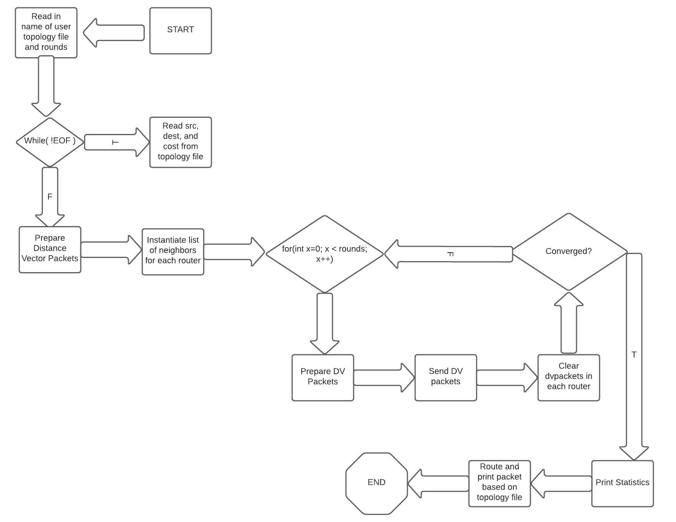

Classes:

